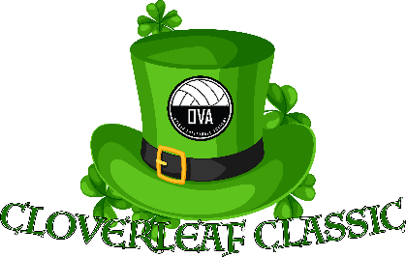
Tournament Guide
Cloverleaf Classic

Basic Information
The Cloverleaf Classic is a two-day AAU sanctioned event from March 16-17, 2024, played at Oviedo Volleyball Academy.
All matches will be either best of three sets to 25 with a deciding set to 15 OR three sets to 25. Please pay attention to pool description on Sportwrench.com for clarification within each pool/division. There will be no caps in any set and all teams will play the equivalent of at least 4 matches.
Ticketing
Tickets must be purchased online at SportWrench.com. Tickets are $12 for a daily-pass or $20 for the weekend. Each ticket holder is required to provide proof of identification each time they enter the facility. Children 10 and under are free.
Tie-Breaker Procedures
There will NOT be any tie-breaking games played.
In the case of a tie, the teams will be ranked by head-to-head results in case of a 2-way tie in matches or, in the case of 3 or more teams tied in matches: set percentage. If two teams are still tied on set percentage, the tie will be broken by the head-to-head result of their match OR if three or more teams are still tied the tie will be broken by point percentage. This description coincides with the USAV Tie-Breaking Decision Tree procedure.
Officiating
A first official (R1) will be provided for each match. Work teams will be required to provide a second official (R2), two-line judges, a scorekeeper, a visual scorekeeper, and a libero tracker. For 11/12 Club and 13/14 Club divisions, a rostered adult must serve as the R2 during officiating duties.
Protests
If a protest is to be filed, it must be done at the time of the incident.
The first referee is obligated to acknowledge and record all protests. ONLY THE FLOOR CAPTAIN MAY FILE PROTESTS. The exception to this rule applies to the 14U and younger divisions, where the acting team coach may act.
All protests will be handled by the Protest Committee and their decision is binding. A Protest Committee will ideally consist of any two of the following:
● Tournament Director
● Assistant Tournament Director
● Site Director/Manager/Tournament Assistant
● Head Official
● Highest rated available official or a non-involved Club Director
All efforts will be made to ensure two of the above members are able to appear at a protest, but protests can be completed with just the Tournament Director, Assistant Tournament Director, Site Director, or Head Official, if needed.
Other Facility Rules
Spectators are encouraged to relocate away from the court when their athlete is not playing in an effort to open up space and seating for spectators of teams currently playing.
We ask that you please refrain from bringing coolers and outside food/drink into the facility. Concessions (snacks and drinks) will be available and must be consumed in designated areas of the facility.
LAWN CHAIRS ARE NOT PERMITTED IN THE FACILITY.
Athletes are not permitted to impede onto another playing court during a rally. The ball will be deemed out of play if this occurs.
There will be no ball-handling on any empty courts or spectator areas.
There will be a no tolerance policy for misbehavior by players/teams and spectators in the facility.
Violation of these policies or any other general misbehaviors may result in immediate dismissal from the facility for the remainder of the day/tournament.
Awards
Awards will be given to first and second place finishers in Gold Brackets/Pools, and Silver Bracket/Pool first place finishers.

