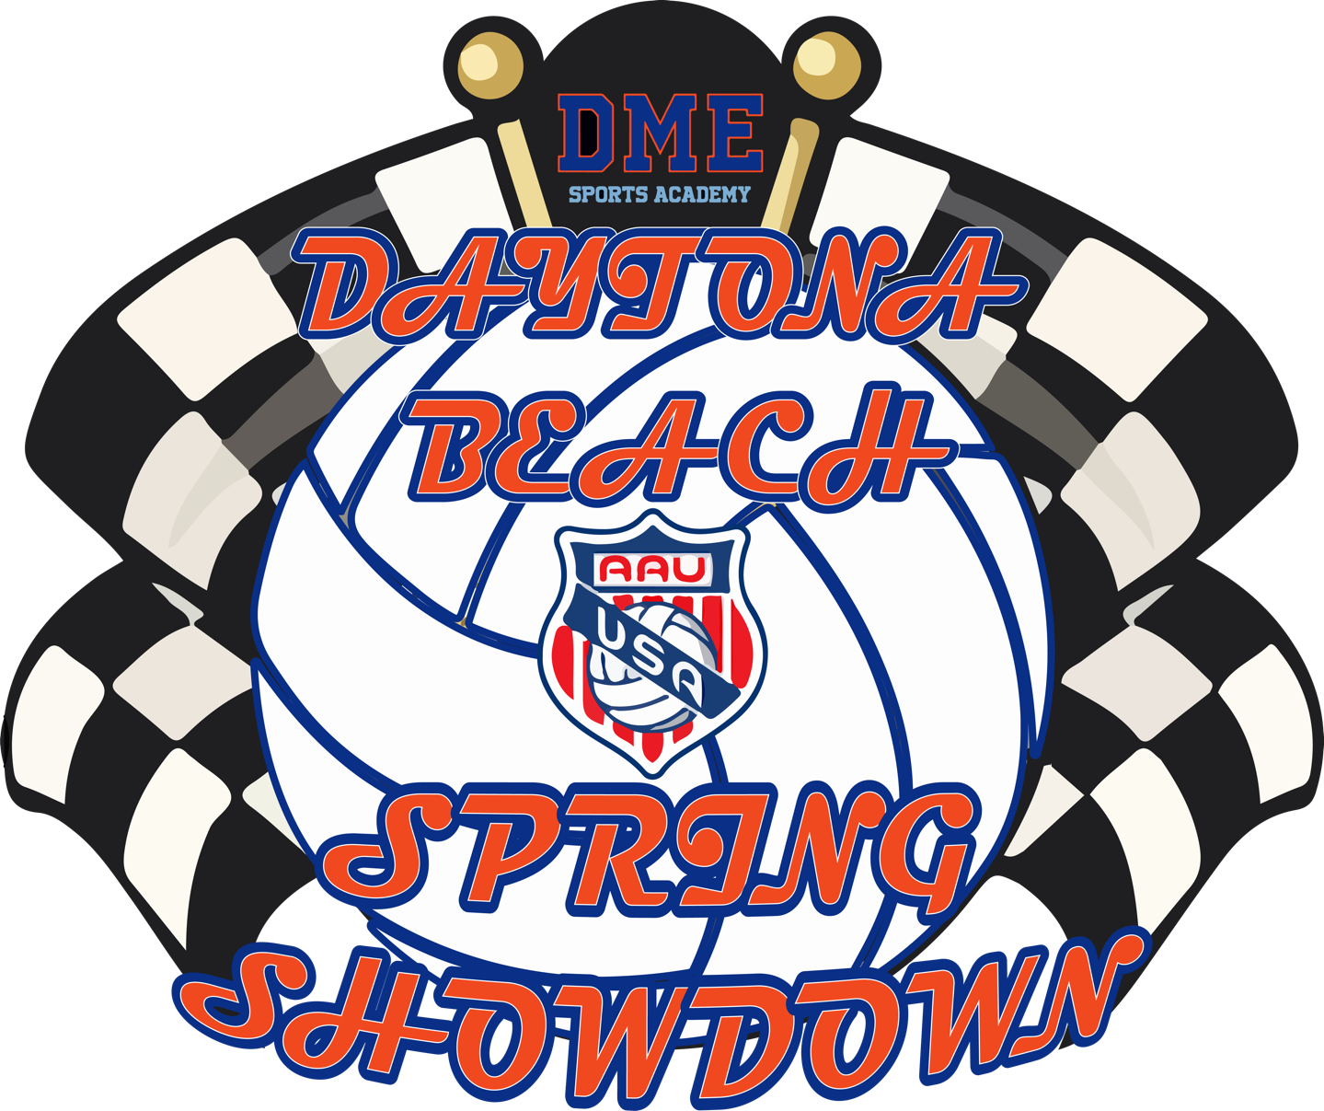

Tournament Guide
DME Volleyball Academy
2441 Bellevue Ave Daytona Beach, FL 32114

Event Details
The DME Daytona Beach AAU Spring Showdown event is formatted as a two, one day events in which certain age divisions will compete on April 15 & 16, 2023 at the DME Volleyball Academy 2441 Bellevue Ave Daytona Beach, FL 32114.

Tentative Age Division Dates & Waves (Subject to change)

Saturday April 15, 2023
AM Wave: 12 Club, 14 Club
PM Wave: 16 Club, 18 Club

Sunday April 16, 2023
AM Wave: 11 Club, 13 Club
PM Wave: 15 Club, 17 Club

All matches will be either best of three sets to 25 with a deciding set to 15 OR three sets to 25. Please pay attention to pool description on Sportwrench.com for clarification within each pool/division. There will be no caps in any set and all teams will receive the equivalent of 7 matches.

All teams must have a rostered adult present at the officiating table during officiating duties. For age divisions 14 & under, a rostered adult must serve as the R2 during their officiating assignment.

Tie Breakers:

There will NOT be any tie-breaking games played.

In the case of a tie, the teams will be ranked by head-to-head results in case of a 2-way tie in matches or, in the case of 3 or more teams tied in matches: set percentage. If two teams are still tied on set percentage, the tie will be broken by the head-to-head result of their match OR if three or more teams are still tied the tie will be broken by point percentage. Note that the 3 or more teams tied procedure is slightly different than previous years based on the updated procedures used at the AAU National Championship event.

Awards:

Awards will be given to first and second place finishers in Gold Brackets and first place finishers of Silver and Bronze Brackets. Award information will be given at the court upon the completion of the division championship match.

Officials:

A first official (R1) will be provided for each match. Gold Bracket finals will also provide a paid second official (R2).

Protests:

If a protest is to be filed, it must be done at the time of the incident.

The first referee is obligated to acknowledge and record all protests. ONLY THE FLOOR CAPTAIN MAY FILE PROTESTS. The exception to this rule applies to the 14U and younger divisions, where the acting team coach may act.

All protests will be handled by the Protest Committee and their decision is binding. A Protest Committee will ideally consist of any two of the following:

- Tournament Director
- Assistant Tournament Director
- Site Director
- Head Official
- Highest rated available official or a non-involved Club Director

All efforts will be made to ensure two of the above members are able to appear at a protest, but protests can be completed with just the Tournament Director, Assistant Tournament Director, Site Director, or Head Official, if needed.

Other Facility Rules:
Parking at DME Volleyball Academy is free and limited. Teams are encouraged to carpool much as possible.

Athletes are not permitted to impede onto another playing court during a rally. The ball will be deemed out of play if this occurs.

Due to incidents in previous years, there will be a no tolerance policy for misbehavior by players/teams and spectators in the venues:

- Ball Handling is NOT allowed outside of the playing facilities.
- Lawn chairs are NOT allowed in the facility
- Coolers are NOT ALLOWED in ANY of the facilities.
● Only water and sports drinks may be brought inside the facility.

All food and drinks must be consumed in the concessions area of the facility.

All parents and spectators are expected to abide by the rules and guidelines put forth by the Tournament staff and Event Facility while attending the event.
Violation of these policies or any other general misbehaviors may result in immediate dismissal from the facility for the remainder of the day/tournament.

