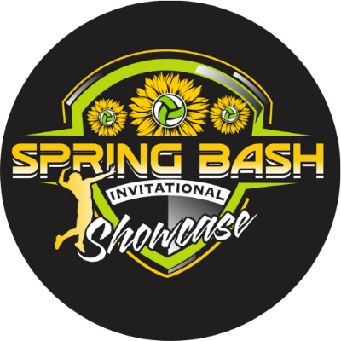

Tournament Guide
March 12-13, 2022
Fort Lauderdale, FL
The Greater Fort Lauderdale – Broward Convention Center
1950 Eisenhower Blvd, Fort Lauderdale, FL 33316

Information:
The 2022 Florida Spring Bash Showcase event is a two-day event from March 12-13, 2022, played at
The Greater Fort Lauderdale - Broward Convention Center.
1950 Eisenhower Blvd, Fort Lauderdale, FL 33316

All matches will be either best of three sets to 25 with a deciding set to 15 OR three sets to 25. Please pay attention to pool description on Sportwrench.com for clarification within each pool/division. There will be no caps in any set and all teams will receive the equivalent of 5 matches.

All teams must have a rostered adult present at the officiating table during officiating duties per the USAVA rules of the FL Region. For 11U – 14U Divisions, we ask that an adult serve as the R2 during their teams officiating assignment.

Tie Breakers:

There will NOT be any tie-breaking games played.
In the case of a tie, the teams will be ranked by head-to-head results in case of a 2-way tie in matches or, in the case of 3 or more teams tied in matches: set percentage. If two teams are still tied on set percentage, the tie will be broken by the head-to-head result of their match OR if three or more teams are still tied the tie will be broken by point percentage. Note that the 3 or more teams tied procedure is slightly different than previous years based on the updated procedures used at the USAV Junior National Qualifiers and National Championship events.

Awards:

Awards will be given to first, second, and third place finishers in Gold Brackets and first place finishers of Silver and Bronze Brackets/Pools. Award information will be given at the court upon the completion of the division championship match.

Officials:

A first official (R1) will be provided for each match. Gold Bracket finals will also provide a paid second official (R2).

Protests:

If a protest is to be filed, it must be done at the time of the incident.

The first referee is obligated to acknowledge and record all protests. ONLY THE FLOOR CAPTAIN MAY FILE PROTESTS. The exception to this rule applies to the 14U and younger divisions, where the acting team coach may act.

All protests will be handled by the Protest Committee and their decision is binding. A Protest Committee will ideally consist of any two of the following:

- Tournament Director
- Assistant Tournament Director
- Site Director
- Head Official
- Florida Region of USA Volleyball Board Member
- Highest rated available official or a non-involved Club Director

All efforts will be made to ensure two of the above members are able to appear at a protest, but protests can be completed with just the Tournament Director, Assistant Tournament Director, Site Director, or Head Official, if needed.

Other Facility Rules:
Parking at Fort Lauderdale Convention Center is $10 and limited. Teams are encouraged to carpool much as possible.

Spectators are encouraged to relocate away from the court when their athlete is not playing to provide seating for spectators whose teams are playing and to maintain social distancing.

Athletes are not permitted to impede onto another playing court or concrete surface during a rally. The ball will be deemed out of play if this occurs.

Due to incidents in previous years, there will be a no tolerance policy for misbehavior by players/teams and spectators in the venues:

- Ball Handling is NOT allowed outside of the playing facilities.
- Coolers and outside food and drink are NOT ALLOWED in ANY of the playing facilities
- Only water and sports drinks may be brought inside the facility.

Violation of these policies or any other general misbehaviors may result in immediate dismissal from the facility for the remainder of the day/tournament.
All spectators will be asked to abide the USAV FL Region Spectator Code of Conduct for this event. Failure to comply with these guidelines may result in removal from the facility
USAV FL Region Spectator Code of Conduct

